EMPLOYEE SELF-EVALUATION FORM

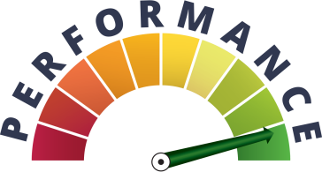

PLEASE FILL THIS PAGE IN CAPITAL LETTERS

Name of the Employee
DOB
ASM Employee ID
Business Unit / Group
Designation
Date of Joining
Highest Qualification
Total Experience
Relevant Experience
ASM – AMAT Experience
AMAT PSID

Date: Signature of the Employee

EMPLOYEE SELF-EVALUATION FORM

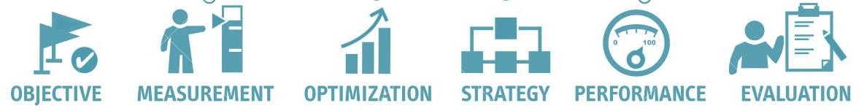

On receiving the Assessment form, the employee has to FILL all particulars

Job description

- How would you describe your main responsibilities?

- Have these responsibilities changed over time

- Do you carry out any other tasks, and if so, which?

- What could your immediate manager do to help you be more successful in your job?

Performance vs Achievements

- What action have you taken to fulfil your responsibilities?

- Do you feel you've been successful during this period?

- Do you think you could have done anything better?

- How do you think you have contributed to your BU/Group during this period?

- What are your main strengths?

- In which areas do you feel you could improve?

- Are you aware of the purpose of Time Sheet?

- Are you aware of the Time Sheet policies and guidelines?

- Do you expect a follow up / reminders on Timesheet Submission?

Objectives


- What objectives have you reached during this period?

- Which ones did you not manage to achieve, and why?

- What objectives do you propose for the next period?

Name: Designation: Date:
Signature of Employee

